Webserv Project Task Division for 2-Person Team
Team Members
- Bernardo: Core server, configuration parser, routing, low-level networking
- Lien: HTTP parsing/response, CGI handling, uploads, dynamic features

High-Level Division Strategy
- Bernardo handles the server architecture, socket programming, configuration system, and routing logic.
- Lien implements HTTP protocol handling, response creation, file uploads, CGI integration, and dynamic route features.
- Both collaborate on testing, debugging, and documentation.

Task Timeline and Assignment
Phase 1: Initial Setup & Configuration Parser (Days 1–7)
Bernardo | Lien
Design server architecture and data structures | Design config grammar
Set up socket initialization, listen() and accept() logic | Build parser for config file and fill server config struct
Parse interface:port, max body size, error pages | Parse routes: accepted methods, redirection, root, etc.
Setup git repo, CI script, project skeleton | Validate parser with test .conf files
Phase 2: HTTP Request/Response & Routing (Days 8–14)
Bernardo | Lien
Implement non-blocking I/O using poll() or select() | Implement HTTP request parsing (method, URI, headers)
Handle connection pool, client socket queue | Implement response builder (status codes, headers)
Setup request-to-route matching using config rules | Add MIME type support and file type detection
Serve static files based on route root | Implement redirection logic
Phase 3: Directory Listing, Error Pages, Method Handling (Days 15–21)
Bernardo | Lien
Implement default file serving for directories | Implement directory listing (auto-index)
Implement method restrictions per route | Implement custom error page loading
Enhance router to support multiple routes per server | Handle oversized body rejection using configured limit
Write unit tests for routing/method validation | Test error scenarios (404, 403, 500)
Phase 4: File Uploads & CGI Execution (Days 22–30)
Bernardo | Lien
Create logic for file uploads: parse multipart form, save to disk | Implement CGI environment setup and execution
Add route config for upload path and verify file write | Add support for executing PHP or Python CGI scripts
Handle file permission errors and report them | Unchunk chunked bodies before CGI
Cleanup temp files after upload or CGI run | Handle CGI output: headers, content, EOF detection
Phase 5: Virtual Hosts, Polishing & Testing (Days 31–38)
Bernardo | Lien
Add support for multiple server blocks on different host:port | Support virtual hosts using Host: header and server_name
Final cleanup of config system | Add integration tests for every feature
Improve performance with keep-alive support (optional) | Add CGI relative path and working directory fix
Fix bugs, edge cases, and memory leaks (Valgrind) | Write final test cases and prepare demo config files
Phase 6: Evaluation Prep & Delivery (Days 39–42)
Bernardo & Lien
Create default .conf file with all features used
Create test HTML, CGI scripts, and upload form
Build a script to run test scenarios (curl / browser)
Final README.md with instructions, architecture diagram, config reference
Dry run: do a mock eval using the subject sheet

Teamwork Tips
- Use Git branches (e.g., feature/parser, feature/cgi-handler)
- Sync daily and merge frequently
- Code review weekly
- Maintain clean and modular interfaces (Request, Response, Route, ServerConfig)
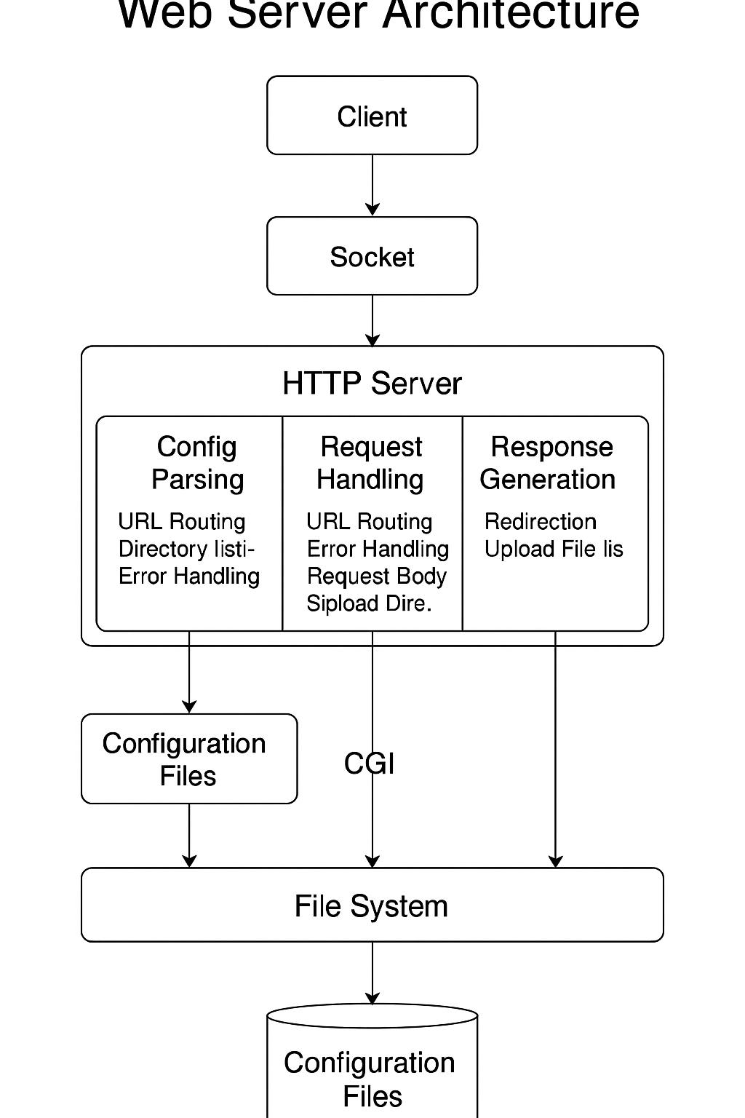
Designing the configuration grammar for your 42 Webserv project means defining a clear and structured syntax for your server configuration file (usually .conf). Here's a sample design with explanations.

🧩 Configuration Grammar Design
🔧 General Structure
server {
listen 127.0.0.1:8080;
server_name mywebsite.com;

error_page 404 /errors/404.html;
client_max_body_size 2M;

location / {
root /var/www/html;
index index.html;
autoindex off;
methods GET POST;
}

location /upload {
root /var/www/uploads;
upload_enable on;
upload_store /var/www/uploads;
methods POST;
}

location /cgi-bin {
root /var/www/cgi-bin;
cgi_enable on;
cgi_extension .py;
}

location /redirect-me {
return 301 http://example.com/;
}
}

🔍 Grammar Specification (EBNF-like)
config ::= { server_block }

server_block ::= "server" "{" server_directives location_blocks "}"
server_directives ::= { listen | server_name | error_page | client_max_body_size }

listen ::= "listen" ip ":" port ";"
server_name ::= "server_name" domain ";"
error_page ::= "error_page" error_code path ";"
client_max_body_size ::= "client_max_body_size" size ";"

location_blocks ::= { location_block }
location_block ::= "location" path "{" location_directives "}"

location_directives ::= { root | index | autoindex | methods | upload | cgi | return }

root ::= "root" path ";"
index ::= "index" filename ";"
autoindex ::= "autoindex" ("on" | "off") ";"
methods ::= "methods" { "GET" | "POST" | "DELETE" } ";"
return ::= "return" status url ";"

upload ::= "upload_enable" ("on" | "off") ";"
upload_store ::= "upload_store" path ";"

cgi ::= "cgi_enable" ("on" | "off") ";"
cgi_extension ::= "cgi_extension" extension ";"

🧪 Notes
- Each directive ends with a semicolon (;).
- Nested location blocks allow route-specific configuration.
- No need for regex support; only simple path matching (e.g., / or /upload).
- You can extend the grammar by adding new directives.

Would you like a syntax validator or sample .conf parser written in C++ to go with this grammar?

// Minimal Config Parser Skeleton in C++ (simplified version)
#include <iostream>
#include <fstream>
#include <sstream>
#include <string>
#include <map>
#include <vector>

struct Location {
std::string path;
std::string root;
std::string index;
bool autoindex = false;
std::vector<std::string> methods;
bool upload_enable = false;
std::string upload_store;
bool cgi_enable = false;
std::string cgi_extension;
std::string redirection;
};

struct Server {
std::string listen_ip;
int listen_port;
std::string server_name;
std::map<int, std::string> error_pages;
int client_max_body_size;
std::vector<Location> locations;
};

// Utility function to trim whitespace
std::string trim(const std::string& str) {
size_t first = str.find_first_not_of(" \t\n\r");
if (first == std::string::npos) return "";
size_t last = str.find_last_not_of(" \t\n\r");
return str.substr(first, (last - first + 1));
}

// Example function to parse a line
void parse_line(const std::string& line, Server& server) {
std::istringstream iss(line);
std::string key;
iss >> key;

if (key == "listen") {
std::string address;
iss >> address;
size_t colon = address.find(":");
server.listen_ip = address.substr(0, colon);
server.listen_port = std::stoi(address.substr(colon + 1));
} else if (key == "server_name") {
iss >> server.server_name;
} else if (key == "client_max_body_size") {
std::string size;
iss >> size;
server.client_max_body_size = std::stoi(size);
} else if (key == "error_page") {
int code;
std::string path;
iss >> code >> path;
server.error_pages[code] = path;
}
// Extend to parse more keys and location blocks
}

int main() {
Server server;
std::ifstream infile("server.conf");
std::string line;

while (std::getline(infile, line)) {
line = trim(line);
if (line.empty() || line[0] == '#') continue;
parse_line(line, server);
}

std::cout << "Parsed server listening on: " << server.listen_ip << ":" << server.listen_port << "\n";
std::cout << "Server name: " << server.server_name << "\n";
std::cout << "Max body size: " << server.client_max_body_size << " bytes\n";
return 0;
}

